Network Project 1

Sepehr Ebadi
9933243
Khordad, 1403

Installation
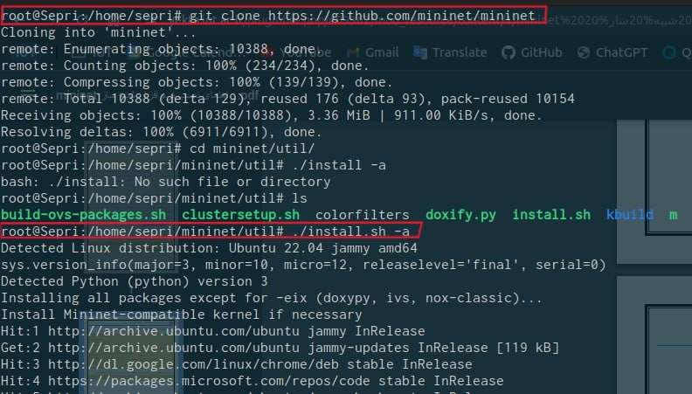
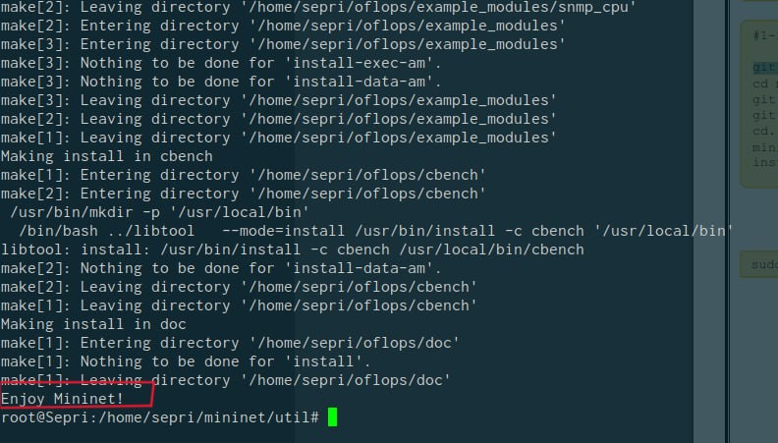

Single Topology
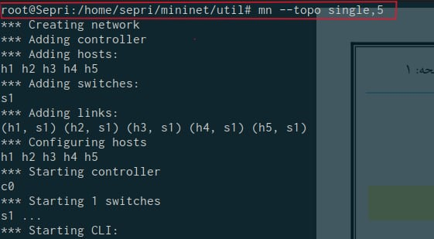
Nodes
Display all the nodes controller, switch and hosts of the topology In the Following example, we have 5 hosts from h1 to h5, one controller c0, and one switch s1.
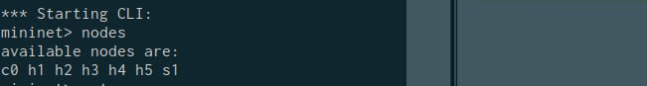
Net
Show the links connection. In the following example, hosts 1 to 5 are connected to switch S1 through eth0. Switch S1 is connected to hosts h1 to h5 through interfaces eth1 to eth5. In conclusion, all the hosts are connected to each other through switch S1.
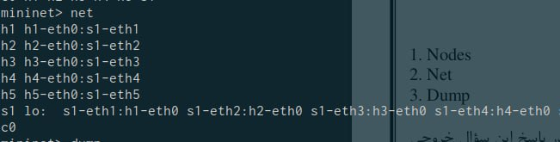

Dump
Provide all the information about the nodes, such as the node's name, the network interface with its IP address, and the process ID. For instance, in the following example host h1-eth IP is 10.0.0.1 with PID 28374, switch s1 loop back interface IP is 127.0.0.1 and controller c0 IP is 127.0.0.1:6653 with PID 28367
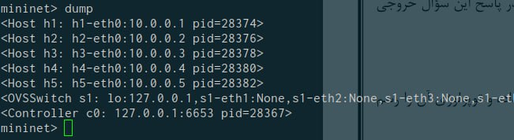

Linear Topology
A linear topology is a type of network topology in which all the network nodes are arranged in a straight line, with each node connected to its nearest neighbors. The first and last nodes in the topology have only one neighbor, while the intermediate nodes have two neighbors. In a linear topology, data can be transmitted in only one direction, from one end of the topology to the other. This makes it easy to add or remove nodes, but it also means that the failure of any one node can result in the entire network being disrupted. Linear topologies are commonly used in small networks, such as home or office networks. They are easy to set up and maintain, and can be implemented using a variety of technologies, including wired and wireless connections. Linear topologies are not well-suited for large networks or networks with high traffic, as they can become congested and suffer from latency and packet loss. In such cases, more complex topologies, such as ring, mesh, or tree topologies, may be more appropriate.

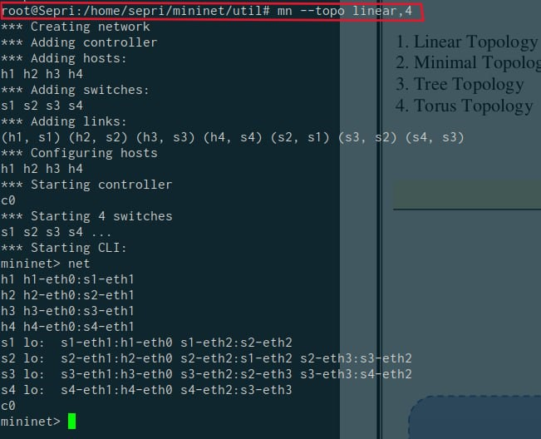

Minimal Topology
A minimal topology is a type of network topology that consists of the smallest number of nodes required to establish network connectivity between them. In other words, a minimal topology is the simplest possible network topology that can achieve a particular level of connectivity. The exact number of nodes required for a minimal topology depends on the specific connectivity requirements of the network. For example, if the goal is to connect two devices together, a minimal topology would consist of a single link connecting those devices. If the goal is to connect three devices, a minimal topology would consist of a triangle topology, in which each device is connected to the other two devices. Minimal topologies are often used in situations where resources are limited or where network complexity needs to be minimized. They can be implemented using a variety of technologies, including wired and wireless connections. While minimal topologies can be simple and easy to set up, they can also be less resilient than more complex topologies. For example, if a single link or node fails in a minimal topology, the entire network may be disrupted. As such, more complex topologies, such as mesh or tree topologies, may be more appropriate for larger or more critical networks.

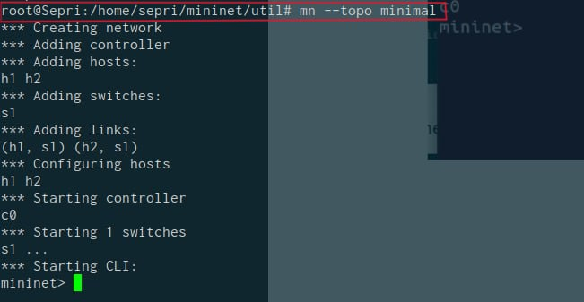

Tree Topology
A tree topology is a type of network topology in which network nodes are arranged in a hierarchical structure, resembling the shape of a tree. In a tree topology, nodes are connected to a central node, which is sometimes called the root node. The root node is connected to one or more nodes, which are in turn connected to additional nodes, creating a branching structure. The tree topology is commonly used in wide area networks (WANs) and local area networks (LANs), and is often used in corporate and enterprise networks. In a LAN environment, the root node is typically a switch or a router, and the end nodes are usually computers, printers, or other network devices. One of the advantages of the tree topology is that it is scalable and can support a large number of nodes. Additionally, it provides a clear hierarchical structure, which makes it easy to manage and troubleshoot network issues. However, one of the disadvantages of the tree topology is that it can be less resilient than other topologies, such as mesh or ring topologies, because a failure of the root node or a single link can cause the entire network to fail. Furthermore, the tree topology can become inefficient as the network grows larger, leading to longer paths between nodes and increased latency. Overall, the tree topology is a commonly used and versatile network topology that provides a balance between scalability and manageability.
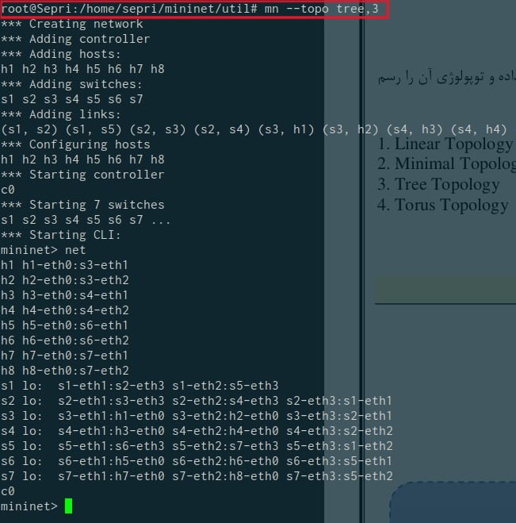

Finding problems with using tcpdump
tcpdump is a powerful tool for network troubleshooting and analysis. In Mininet, we can use tcpdump to capture network traffic and diagnose problems in network.
steps to use tcpdump in Mininet:
1. Open Mininet network topology and start the simulation.
2. Open a terminal window on the host machine.
3. Type the following command to list the available network interfaces: $ifconfig
4. Identify the interface that corresponds to the Mininet network, typically it will have an IP address in the 10.0.0.0/8 range.
5. Use the following command to capture network traffic on the identified interface: $ sudo tcpdump -i <interface> -n -s0 -w <file.pcap>
where:
•<interface> is the name of the network interface you identified in step 4.
•-n option is used to display IP addresses instead of hostnames.
•-s0 option is used to capture the entire packet without truncation.
•<file.pcap> is the name of the file where the captured packets will be saved.
6.Reproduce the problem you are experiencing in your Mininet network.
7. Stop the capture by pressing CTRL-C in the terminal window.
8. Open the captured file in a packet analysis tool like Wireshark to analyze the network traffic and diagnose the problem.
Using tcpdump in Mininet can be very helpful in troubleshooting network problems, as it allows you to capture and analyze network traffic in real-time.

